Jesus Zamora

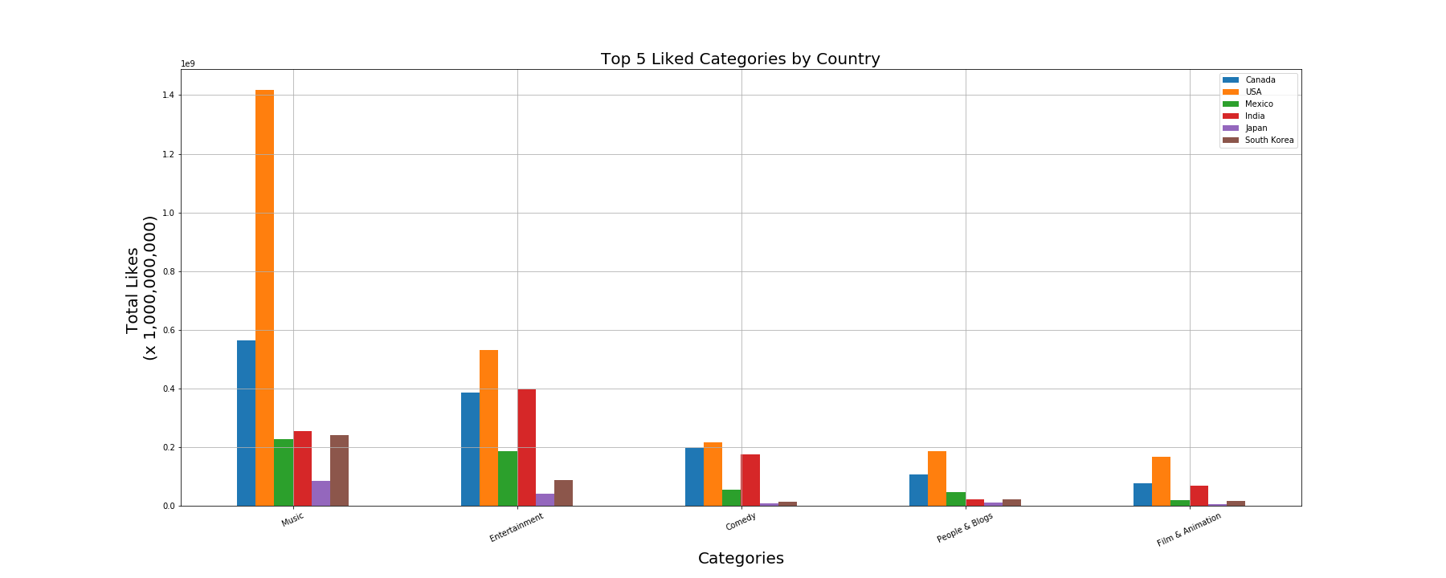 Project 1

In order to get my data I pulled the relevant information that pertained to my questions, category_id, likes, dislikes, and comment count. To get my data I grouped by category ID, then sorted each column by their top values and took the top 5 up based on category_id. Each column was merged together until I had the dataframe with the info I wanted.

**Likes** Analysis

Overall it seems as though the countries we chose, seem to follow the trend from the US. It’s interesting to note that music in the US has an astronomical number of likes. Top categories by country:

Canada, India -> Entertainment

USA, Mexico, Japan, South Korea -> Music

**Engagement**: Music and Entertainment seem to illicit the most likes which makes sense since those are the top categories. Its interesting that see that besides Canada and the US, India seems to get more likes but not nearly what you would expect from a country with 1 billion+ people.

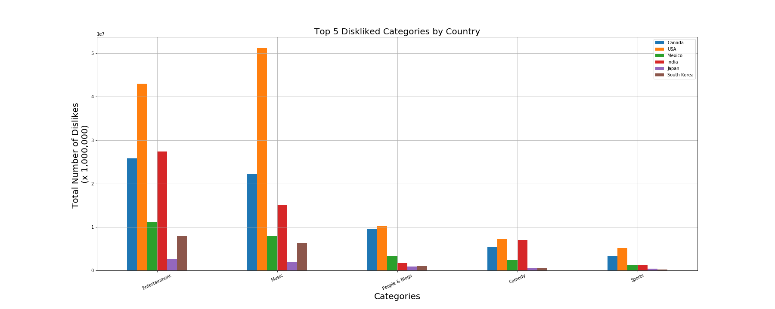Dislikes Analysis

**Dislike and Engagement** Analysis

Canada, Mexico, Japan, South Korea -> Entertainment

USA -> Music

Based on the categories in likes I expected Entertainment and Music to be the top categories for dislikes. Although it seems as though more countries interact with likes, that’s a bit misleading because the number of dislikes are way lower than the total number of likes. As before Canada, USA and India lead the charge with more interaction with dislikes. For dislikes its interesting to note that the last of the top five has been replaced by sports. Sports didn’t show up in likes but showed up in dislikes, so it seems as though people that are watching with sports videos are more likely to interact with the dislike button than the like button. Overall the dislike button gets way less interaction than the like button. Our top disliked category has a little over 5 million dislikes while our top like has 1.4 billion likes. I think with further analysis that would be an interesting question to answer. Why do people interact with like? Are they using it as a bookmark? Do people tend to close out videos they don’t like etc.

Most Commented Analysis

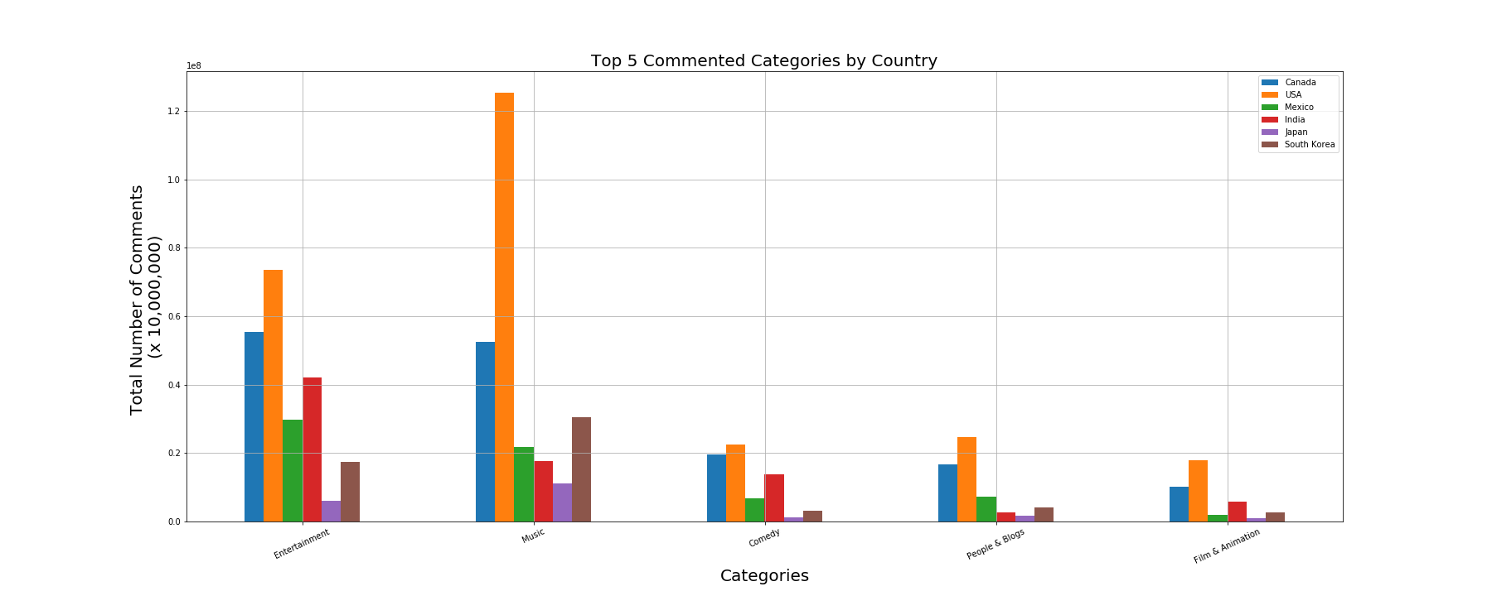

Canada, Mexico-> Entertainment

USA , India, Japan, South Korea-> Music

For most commented the same categories from likes have reappeared. It’s interesting to note that music and entertainment seem to get more comments than dislikes in the categories. It seems as though people interact more with videos they like than with videos they don’t. One thing about comment count is that it does not take into account if it was a positive comment or negative. So while they are interacting with comments it doesn’t mean they like the video. Another possible question could be into looking into positive and negative comments. Are people not interacting with the dislike button but they are voicing their opinions in the comments?